Why 1971?
The year was 1971. I had just returned to Redstone Arsenal, AL in late 1970 after living West Germany for the previous three years. I met my friend Mickey on the first day I lived on Redstone as he lived across the street. One of the games Mickey had was the beautiful Super Bowl IV set from Tudor. By 1971 I had acquired my own set which was a Tudor model 500 featuring the Bears at the Giants. Our long electric football adventure had begun. We did have other activities like Redstone Arsenal Youth Sports Association football and baseball, hiking, historical miniatures and later on, girls. However, electric football ran as an undercurrent through our childhood and pre-teen years.

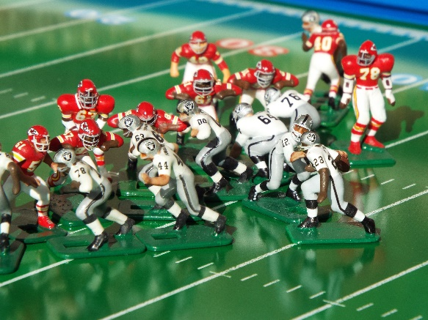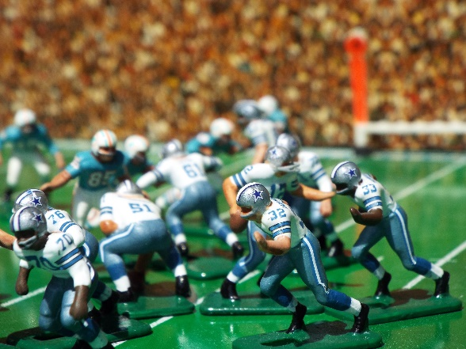
We played electric football whenever we had a chance. We each had our own leagues of 12-14 teams. We tried to acquire different teams so that there was little duplication in our two leagues. I received a 1973 Tudor Championship size 620 with four NFL teams for Christmas in 1973. We kept records and even managed to stage two Super Bowls during those years. We still have those records. My friend Mickey is two years older than I and he lost interest first. I continued to play into my twenties. By then I had aborted the incomplete season I had already begun, and acquired all the teams so I could run my own season. However, college, dating, marriage, other hobbies and eventually my career increasingly dominated my time. By the mid 1980’s I no longer played electric football as I had time for only one hobby and that was Historical Miniatures Gaming. However, I kept my set and teams.

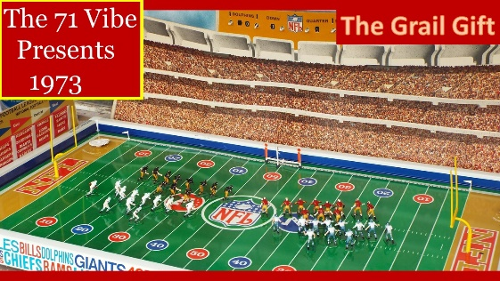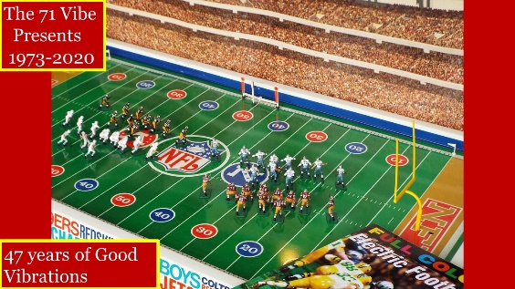
Now I will fast-forward to 2015. My friend Mickey discovered that people were still playing electric football. We once again became interested and I revived my early 1980s league and began to try and finish the ten-game season which I had abandoned at game 7. I also acquired a new 24 “ X 48” set from Ricardo Riley, and later a Warrior board from Jerry McGhee in Florida. Mickey and I picked up our Warrior Boards while attending an Historical Miniatures convention in Orlando. I completed that previously unfinished season with my 1980s teams. The Cleveland Browns won the Super Bowl. Around the end of that season, I acquired a group of custom figures from Larry Walker with plans to create the 1971 Washington Redskins.
The 1971 Redskins uniform was my absolute favorite the Skins ever wore. I chose 1971 for that reason and due to the fact that this was the year I first acquired a Tudor Set. I also acquired some custom figures from Larry that became the key players on my 1971 Kansas City Chiefs. I still remembered the season I had never finished with my 1970s teams and which I lovingly referred to as my “lost season”. I looked at the old records of that season and realized I could finish that season with a minor investment in time and money. There were 14 teams in that league. I made the fateful decision to rebuild that league with old Tudor Hog Leg stock as the base.

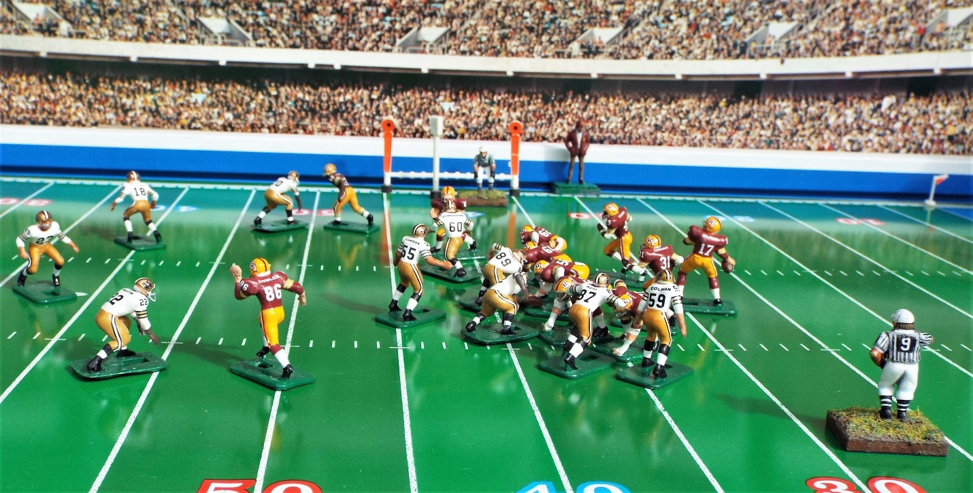
The plan was to create all 14 teams using the original figures I had where possible. The teams were to be similar to my 1970s teams in that they all had 12 players, but now they would have both home and away uniforms. All of these were Hog Leg save for the quarterbacks, for which I used Tudor’s old quarterbacks of the NFL figures. I had to acquire a large number of new Hog Leg stock in order to do so. I wanted these teams to be the visual equal of what I had created with the Redskins and Chiefs so that they would have opponents against which to play. I eventually acquired the figures, painted and applied decals to them. By the end of 2018 I was ready to complete my “lost season”.

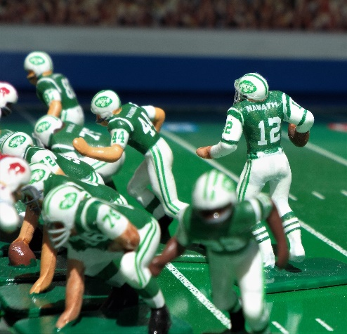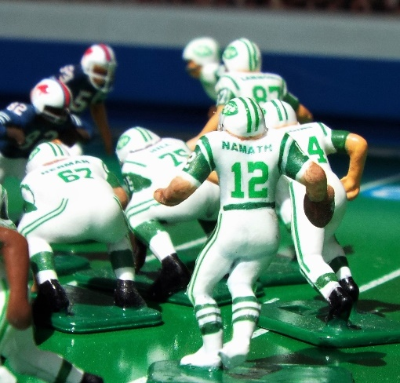
The New York Jets won my “lost season” championship game over my Cincinnati Bengals. Even while finishing that season, which had been abandoned in the mid-70s at game 11, I began to contemplate re-building the entire 1971 season in the same manner. This had been my electric football dream when I was a boy. We were never able to do so despite an abortive attempt around 1973. After another year of work, I completed the basic teams in October of 2019. I launched “The 71 Vibe” in December of that year in order to have an outlet for my electric football photography, videos and other creative material. Meanwhile my friend Mickey had started to play again with an eclectic mix of USFL and NFL teams from the 70s and 80s. During this time, I made the decision to create full line ups for all 26 of my 1971 NFL teams. Tudor launched their new Mean 13 figures during this timeline, and they worked perfectly with my old Hog Leg stock. I asked Blaine Tsukayama of 808 sculpts to create kickers and holders for my league and also for the punters, which came from Next Level Authentics. I also contacted J.C. Davis from Undefeated Figures, who agreed to create figures reduced in scale to match my 1971 teams. I have a large number of these figures integrated into the line ups of my teams.

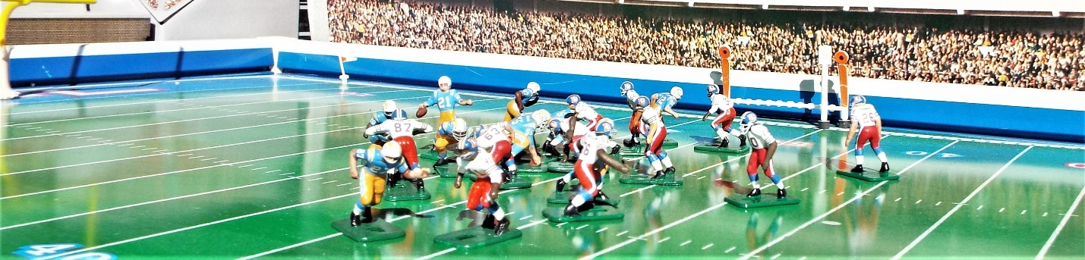
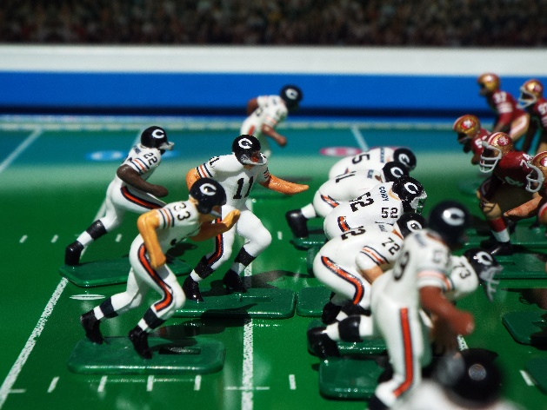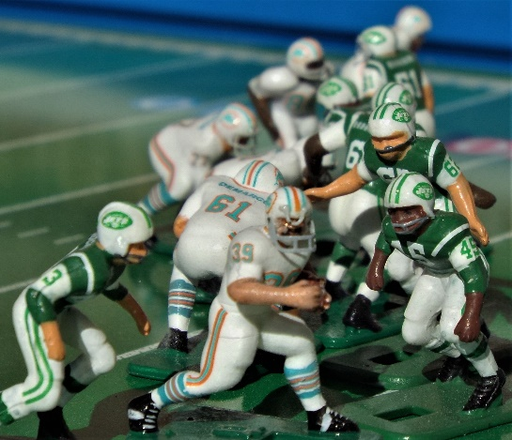
In November, I completed painting and decals on the full rosters of all 26 teams that played in the 1971 season. I am now at round (game 7) of the full 1971 schedule as the NFL played it almost 50 years ago. I hope to complete the season during that 50th anniversary year in 2021. My friend Mickey has now adopted my 1971 St. Louis Cardinals and has run them over the last three rounds. Through The 71 Vibe, I also have an outlet for my photography and my sarcastic wit, which I also incorporate into my promotion of the page. When done with the 1971 season, I plan to publish a book which will be done in the style of the old NFL Prolog Magazine using my photography and content I have created during the process I described in this article. There are a lot of “publish on demand” companies now that should make that perfectly feasible.
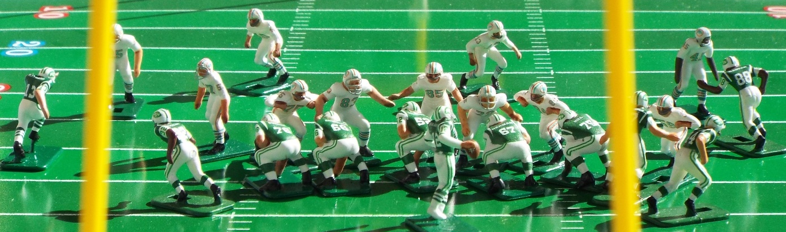
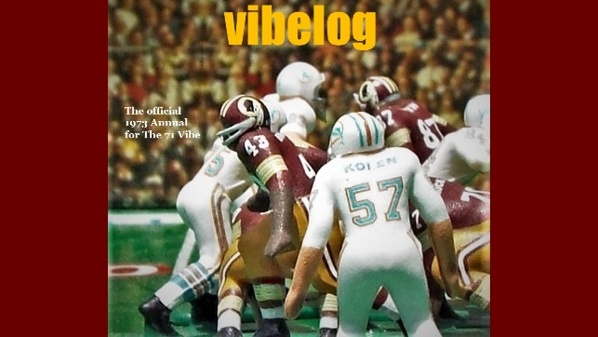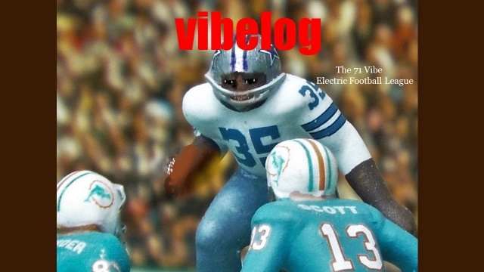

What is next for The 71 Vibe? I am already working on creating the additional figures I will need to play the 1972 season. I will adapt many of the figures I already have, but 1972 was a different animal. How could I have the 72 Steelers without Franco Harris or the 72 Packers without McArthur Lane? There is no way I will use my 1971 Redskins to complete the 1972 season! So the creative process continues. All of those records from the early 70s along with my “how to” instructional videos are on The 71 Vibe page on Facebook. I have no plans to change the name of The 71 Vibe. As I always say when promoting the page, it’s about the 70’s baby, not just 1971!

Bill Moreno
Thanks to
Tudor Games
J.C. Davis of Undefeated Figures
Bryan Nutt of Beenutt Decals
Jerry McGhee
Ricardo Riley
Blaine Tsukayama of 808 Sculpts
Next Level Authentics
Larry Walker (posthumously)
Mitchell Bates (my friend Mickey)

